CCIS 2010 August 23-26, SJC-Brazil

TITLE [font size 12]

First Author¹, Second Author², Third Author³

¹Affiliation, city, country, e-mail
²Affiliation, city, country, e-mail
³Affiliation, city, country, e-mail

The abstract should be written in English. Begin the abstract with the title, which should be brief and self-explanatory. In the header, put the author name(s) in a single line if possible, separated by commas. The name of the author that will present the work must be underlined. The affiliations should be informed in a summarized way, using different lines. Connect the name of each author with his affiliation by means of a numeric calling (superscript). Do not abbreviate the first author’s name. When there is an intermediate name the Author’s name must be abbreviate as in the following example: Reinaldo R. Rosa. It is recommended to refer the main published papers related to your work using numbers like here [1]. When there are more then 2 authors in a given reference you must write only the first author´s name and “et al.” for the others (as in the example below). Figures and mathematical formulas are optional. Figure caption must be like in Fig. 1. Note that Title uses font size 12, authors name use font size 10 and Author’s affiliation, figure captions, Keywords and References use font size 9. The main text must be written using font size 10.

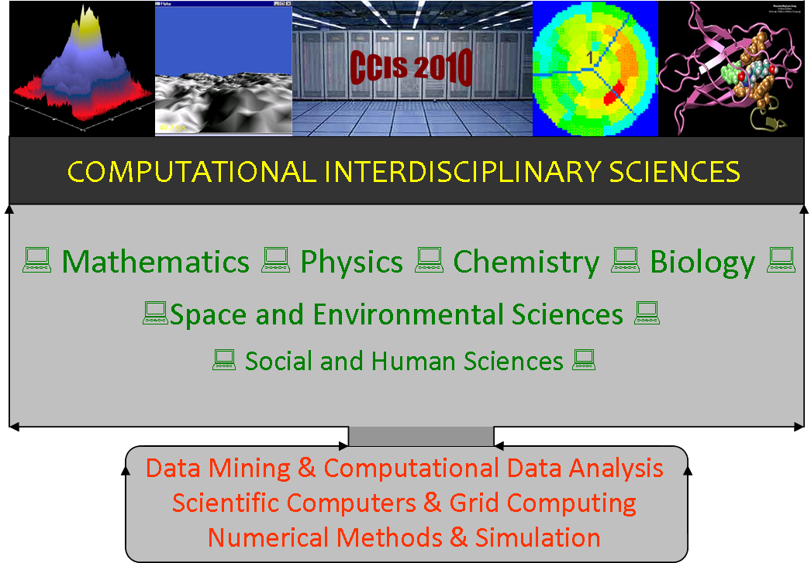

Fig1. Please try to use figures preferably in gray scale.

At least the first keyword must be chosen among the following topics: Computational Mathematics, Computational Physics, Computational Chemistry, Computational Biology, Scientific Computing in Social and Human Sciences, Scientific Computing in Multidisciplinary Topic, Scientific Computing for General Applications.

Keywords: First word, second word, third word. (maximum of six).

References:

[1] Veronese, T.B. et al.. Generalized numerical lattices for time series representation in complex data systems, Journal of Computational Interdisciplinary Sciences 1(2):175-184,2009.

