
INPE – National Institute for Space Research
São José dos Campos – SP – Brazil – July 26-30, 2010

TITLE

First Author1, Second Author2, Third Author3

1Affiliation, city, country, e-mail
2Affiliation, city, country, e-mail
3Affiliation, city, country, e-mail

keywords: First word, second word, third word. (maximum of five), among the options: Applications in Engineering and Nanoscience; Applications of Dynamical Systems in Medicine and Health Sciences; Applications of Nonlinear Sciences; Astrodynamics; Bifurcation theory and analysis; Celestial Mechanics; Chaos in Hamiltonian Systems; Chaotic Dynamics; Climate Dynamics; Collective Phenomena; Communication with Chaos; Complex Networks; Control of Chaos and applications; DNA Translocation Dynamics; Dynamics of Biosystems; Dynamics of Granular Materials; Fluid Dynamics, Plasma and Turbulence; Formation and Dynamics of Patterns; Neuronal Dynamics; Optoelectronic and Granular Matter; Population Dynamics and Epidemiology; Self-organization; Stochastic Dynamics; Synchronization; Time series analysis.

The extended abstracts should be written in English. Begin the extended abstract with the title, which should be brief and self-explanatory. In the header, put the author name(s) in a single line if possible, separated by commas. The name of the author that will present the work must be underlined. The affiliations should be informed in a summarized way, using different lines. Connect the name of each author with his affiliation by means of a numeric calling (superscript).

The extended abstract should be edited in one to two A4 pages format (21.0 x 29.7 cm). The upper and lower margins should be of 25 mm; the left margin 20 mm and the right one 12 mm. The text must be written in two columns of 86 mm each, with a space of 6 mm between the columns.

Table 1 – Sizes (in points) and font styles.

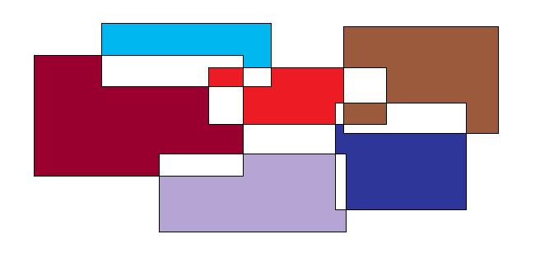
Figure 1 – Example of figure

The figures may be in black and white or in color. Color figures will be reproduced in the proceedings in tons of gray. In all graphs, abscissas and ordinates must be identified with symbols and units. Care must be taken in using values at the scales so that they keep readable when the graph is reduced to fit in the column. It is recommended to insert the figures in such a way that they produce a file with the smallest size possible.

The equations must be numbered consecutively through the text. Equation numbers must be put into parenthesis and shifted to the right as showed in the following example:

(1)

References

[1] P.D. Dresselhaus, Y. Chong, J.H. Plantenberg, and S.P.
Benz, “Stacked SNS Josephson Junction Arrays for
Quantum Voltage Standards,” IEEE Transactions on
Applied Superconductivity Vol. 13, No. 2, pp. 930-
933, June 2003.

[2] Y. Chong, C. J. Burroughs, P. D. Dresselhaus, N. Hadacek, H. Yamamori, and S. P. Benz, “Practical High-Resolution Programmable Josephson Voltage Standards using Double- and Triple-Stacked MoSi2-Barrier Junctions,” to appear in IEEE Trans. Appl. Supercond., Vol. 15, No. 2, June 2005.
[3] G. M. Rocha, G. A. Kyriazis, “A Software for the Evaluation of the Stability of Measuring Standards Using Bayesian Statistics”, Proceedings of the 13th International Symposium on Measurements for Industry Applications, pp 386-391, Athens, September 2004.

